21.26: (a) 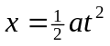
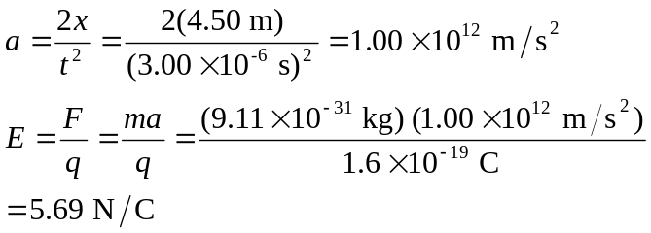

The force is up, so the electric field must be downward since the electron is negative.
(b) The electron’s acceleration is ~ 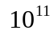 g, so gravity must be negligibly small compared to the electrical force.

